Project Performance Test

Date | 7 July 2026
Team ID | SWTID-20264431
Project Name | Strategic Product Placement Analysis

Model Performance Testing:

S. No. | Parameter | Screenshot / Values
 | Data Rendered | The Retail Sales Dataset was successfully imported into Tableau Public. All records and fields were rendered correctly.  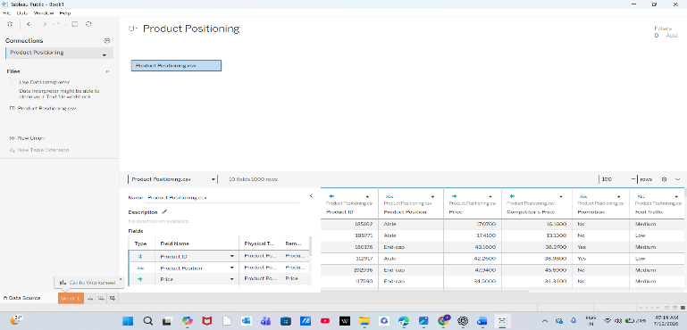
 | Data Preprocessing | The dataset was verified before visualization. Field names, data types, and formatting were checked for consistency. No duplicate or invalid records were found.
3. | Utilization of Filters | All interactive filters worked correctly and updated the dashboard dynamically without any performance issues.  Filters Used:  - Product Position: Aisle, End-cap, Front of Store  - Product Category: Clothing, Electronics, Food  - Consumer Demographics: College Students,  Families, Seniors  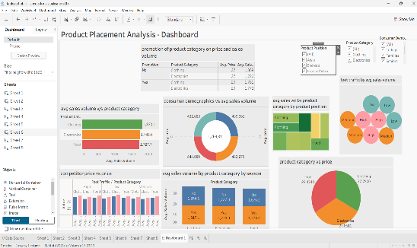
4. | Calculation fields Used | All calculated fields were executed successfully and produced accurate results without any calculation errors.  - Price Calculation  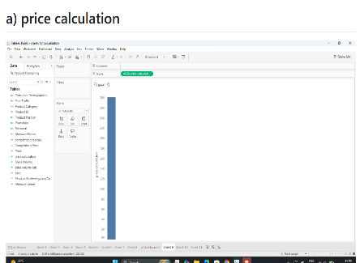  - Competitor price Calculation  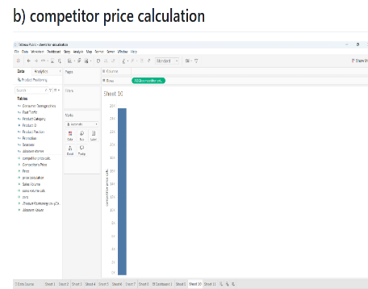  - Sales Volume Calculation  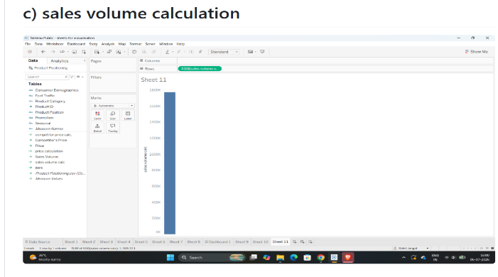
5. | Dashboard design | The dashboard functioned smoothly with all visualizations and interactive filters. All charts loaded correctly, and no performance or display issues were observed.  No of Visualizations / Graphs – 8  - Average Sales Volume vs Product Category (Horizontal Bar Chart)  - Promotion of Product Category on Price and Sales Volume (Text Table)  - Consumer Demographics vs Average Sales Volume (Donut Chart)  - Average Sales Volume by Product Category and Product Position (Tree map)  - Foot Traffic by Average Sales Volume (Packed Bubble Chart)  - Competitor Price vs Price (Clustered Bar Chart)  - Average Sales Volume by Product Category by Season (Stacked Bar Chart)  - Product Category vs Price (Pie Chart)  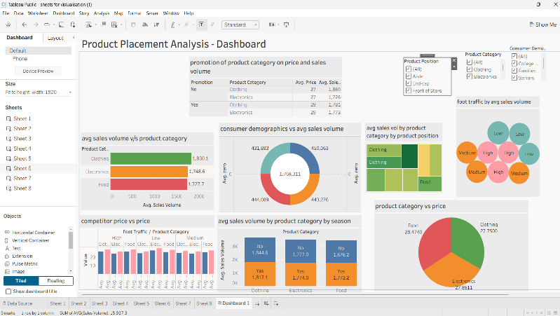
6 | Story Design | The Tableau Story was created successfully. All story points displayed correctly, navigation worked properly, and no errors were encountered during execution.  No of Visualizations / Graphs -3  Story Point 1 – Product Category Performance  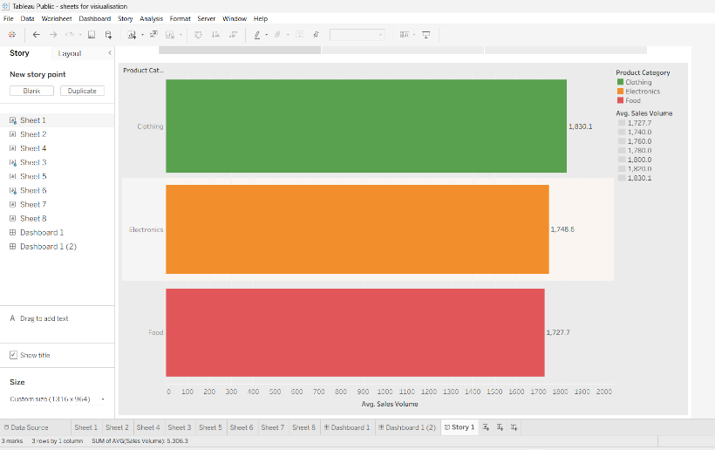  Story Point 2 – Product Position and Foot Traffic Analysis  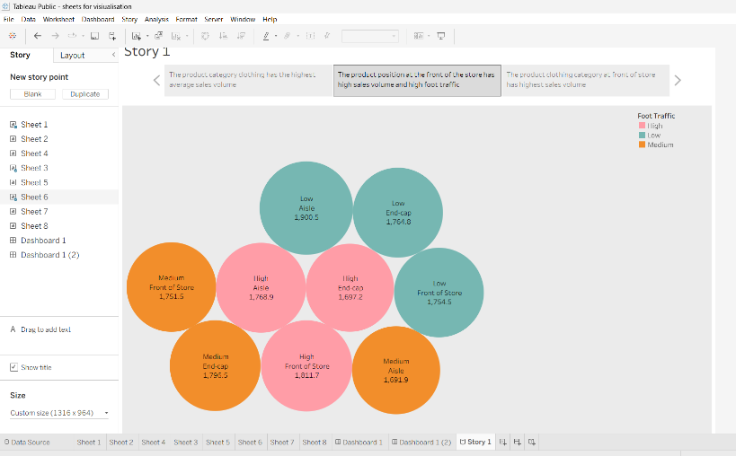  Story Point 3 – Product Position by Category  